FGI Bombay Fashion Week & "Golden Triangle" Tour – March 2015
Only 10 Badges available - US$500 Discount to FGI Members
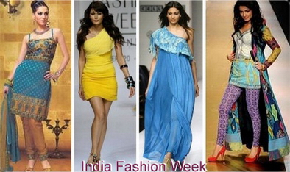
Escorted by Shafiq Hasan - FGI Member - Palm Springs Region
To accommodate people who have date restrictions, we have created 2 packages
- One Tour starts in Delhi on March 15 & ends in Bombay on March 25
- The other Tour starts in Bombay on March 21 & ends in Delhi on March 31
Both groups will be in Bombay on March 22 & 23, to attend the Fashion Shows

Land Package - FGI Members - US$3495 per person, double occupancy
Non-Member - US$3995 per person, double occupancy
Deposit - US$500 per person, Due December 15, 2014
Final Payment Due – January 15, 2015
Single Surcharge on all Tours - US$995
Early Booking Discount - US$200 per person, if full payment made by 12/15/14
All payments Non-Cancelable/Non-refundable - Travel Insurance available

Details can be seen on www.pinnaclefashiontours.com
Contact: Shafiq Hasan at shafiqh1@gmail.com or +1-949-439-6411

This is the 4^{th.} year that Shafiq is escorting FGI members to the Bombay Fashion Week. Everyone had an amazing experience. See one of the great Testimonials

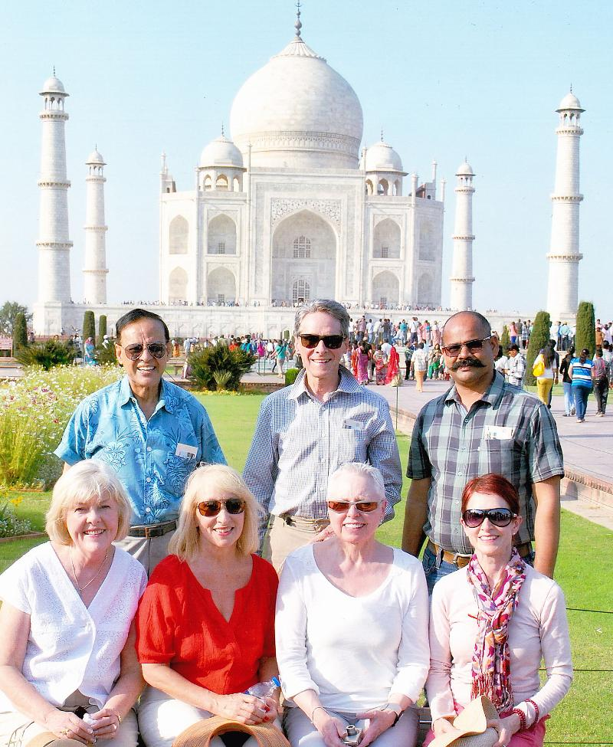 | Our FGI Members trip to India for the Fashion Week in Bombay & Golden Triangle will go down in history as one of the best. The hotels (specially the Taj Mahal Palace in Bombay) and food were all terrific. Your well designed itinerary, extreme personal service & attention to detail were unparalleled. We have fallen in love with the country, its food and its people.  Two things that you specially arranged for us, stand out among many others we enjoyed:  - Visit to Kableshwar & High Tea with Prince Robin: an unforgettable experience  - Amber Fort Jaipur: breathtaking. Loved our private lunch in the Royal Dining Room.  Karen Young, CEO, Young Group

